

**Baxter Primary School**

**Student Handbook**

**2023-2024**

**Our Mission:**

*Educators and leaders of the Putnam County School System provide outstanding, first-rate instruction and support for every student in our district.*

**Our Vision:**

*Each student in the Putnam County School System is* ***Engaged*** *and* ***Inspired*** *to learn, to* ***Achieve*** *academic success and to develop socially and emotionally.  Graduating students are motivated to excellence, equipped with a strong work ethic and committed to family and community.*

High Expectations in a Child Centered Environment

**Every Child, Every Day, No Exceptions**

**125 Elmore Town Road**

**Baxter, TN. 38544**

**Principal: Marsha Wyatt**

**Phone: (931) 858-3110**

**Fax: (931) 858-4644**

**BEE Safe, BEE Respectful, BEE Responsible** 

Dear Baxter Primary Families,

Welcome to Baxter Primary School! The faculty and staff are looking forward to a successful and learning filled school year. The faculty and staff believe that a strong partnership between home and school is essential for all children to be successful. In order for your child to do well, it is necessary for you as the parent and the school faculty to work, cooperate and communicate thoroughly. When we work together, we can often work wonders. You are always welcomed and encouraged to become an active member of our school community.

This handbook has been developed to serve as a guide and a resource for you to become familiar with rules and routines at Baxter Primary School and the Putnam County School System. The school website is also a tool that you can use throughout the year to keep abreast of special activities that may be occurring at school (<http://www.bpshoneybees.com>) and on the Baxter Primary Facebook page.

We encourage every student and parent to review the contents of this handbook and to work with school staff to achieve our academic and safety goals so that all students may enjoy a quality and effective education.

We strive to improve communication between parents, the local community, and the school community. Please contact me with any suggestions or information you may have which will help us improve the effectiveness of our communication and everyone’s experience.

Parents are the child’s first and most important teacher. The teachers, staff and administration of Baxter Primary strive to support your role as a parent. We look forward to working with you to create a learning environment that is caring, nurturing, and supportive of your child’s hopes and dreams.

Sincerely,

Marsha Wyatt

Marsha Wyatt, Principal

**Every Child, Every Day, No Exceptions!**



**Central Office Administration Staff**

Mr. Corby King- [kingc11@pcsstn.com](mailto:kingc11@pcsstn.com) Director of Schools

Mr. Tim Martin- martint3@pcsstn.com Deputy Director of Schools

Mrs. Diana Wood- dwood@pcsstn.com PK- 4 Supervisor

Dr. Bubba Winningham [cwinningham1@pcsstn.com](mailto:cwinningham1@pcsstn.com) 5-12 Instruction

Mr. Chris Pierce- [pierceb2@pcsstn.com](mailto:pierceb2@pcsstn.com) Attendance Supervisor

Mrs. Sheri Roberson- [robersons2@pcsstn.com](mailto:robersons2@pcsstn.com) Supervisor Special Ed. Supervisor

Mr. John Magura- [maguraj@pcsstn.com](mailto:maguraj@pcsstn.com) Maintenance

Mr. Johnny Sloan- [sloanj2@pcsstn.com](mailto:sloanj2@pcsstn.com) Technology Supervisor

Mr. Trey Upchurch- oupchurch@pcsstn.com Student Services

Mrs. Melanie Bussell [bussellm@pcsstn.com](mailto:bussellm@pcsstn.com) RTI/Learning Loss

Mr. Ron Chaffin ron.chaffin@pcsstn.com Transportation

Mrs. Bridgett Carwile- [Bridgett.carwile@pcsstn.com](mailto:Bridgett.carwile@pcsstn.com) Academic Services and Federal Projects

Mrs. Angela Knight- [angie.knight@pcsstn.com](mailto:angie.knight@pcsstn.com) Human Resources

Mr. Mark McReynolds- [mmcreynolds@pcsstn.com](mailto:mmcreynolds@pcsstn.com) Finance

Mr. Buddy Pearson- [buddy.pearson@pcsstn.com](mailto:buddy.pearson@pcsstn.com) Communication

**Putnam County School Board Members BPS PTO Officers**

**Kim Cravens**-**Chair** [kim.cravens@pcsstn.com](mailto:kim.cravens@pcsstn.com) Wendy Jarvis- President

**Dr. Dawn Fry- Vice-Chair**- [DawnFry@charter.net](mailto:DawnFry@charter.net) Katelyn Harmon- Vice President

**Jill Ramsey** - [ramseyp@pcsstn.com](mailto:ramseyp@pcsstn.com) Terann Birdwell - Treasurer

**Lynn McHenry-** lynn.mchenry@pcsstn.com Kayla Winfree- Secretary

**David McCormick**- [mccormick839@hotmail.com](mailto:mccormick839@hotmail.com)



**School Policies**

All students must comply with all policies and procedures of the Putnam County School System and Baxter Primary School. All BPS policies and procedures are aligned with PCSS policies; which can be found at www.pcsstn.com

**School Hours:** School begins at 8:00 a.m.Children arriving before 7:45 are to go to the cafeteria where they are under teacher supervision. Teachers use time before 7:45 to prepare their classrooms for the school day. Breakfast is served in the cafeteria from 7:15-7:45. Supervision of students is provided form 7:15 a.m. until 3:30 p.m. Unless students are enrolled in School Age Child Care (S.A.C.) or 21st Century After School, they should arrive no earlier than 7:15 and leave no later than 3:30 p.m.

**School Office:** Our school office is open Monday through Friday with the exception of school holidays. Daily office hours are from 7:00a.m. - 3:30p.m. Our office staff is always available to answer any questions you might have.

School Office 858-3110 Secretary- Sara Brown

School Fax 858-4644 sara.brown@pcsstn.com

School Age Care (S.A.C.) 858-6339

Cafeteria 858-4238 Book Keeper- Jade Hunter

Transportation 526-9342 [jhunter@pcsstn.com](mailto:jhunter@pcsstn.com)

**Visitors: All Visitors/Parents must enter the school through the front main doors-**With the exceptions of faculty and staff, anyone entering the school building is required to come to directly to the office to sign-in. A visitor’s badge or sticker will then be issued to the visitor. Morning visitors will be asked to sign in and we ask that you *exit the building by 7:55 a.m*. so that classes may begin immediately following announcements. Visitors will only be allowed to travel to classrooms the first two weeks of school. “Independence Day”- August 15th= Students are expected to walk to class with support from the faculty/staff at BPS

Teacher conferences and appointments should be scheduled in advance at a mutually agreeable time. *The goal is to have minimum interruption of classroom instruction and to have a safe environment for all students to learn.*

**Automobile/Bus Policy:**

Doors to the school will remain locked until 7:15 a.m. NO student should be dropped off before 7:15 a.m.

*Please do not use cell phones during pick-up/drop off!

1. The *front parking lot of the building is for* ***buses only***!
2. The *side of the building by the cafeteria is for car riders*. This is a *one way only road*! Please form one lane with **all students exiting their car on the passenger side only.** This is essential for safety reasons. When dropping your child off in the morning, *please pull up* so that 4 to 5 cars can unload at the same time. Children should walk to and from automobiles.
3. Any parent desiring to enter the building mornings, afternoons, or during the day should use a marked space and NOT park in the loading/unloading lane. Parking is available across the street from school, at the gym, or in the parking lot closet to cafeteria (just make sure that you circle all the way around the ballpark and then park in a marked spot.)
4. Please drive extremely slowly anytime you are in the paved areas. No Cell Phones allowed in school zone.
5. Children will not be allowed to return to classrooms while waiting on their ride. If homework, etc. is forgotten parents should park their car and accompany their child back into the building to get forgotten homework, etc.
6. ****Parents are required to pick-up their children through the carline that circles around by the t-ball fields. **Must have a sign in your vehicle with student name on it.** These signs are provided by the school office.

**Attendance: Regular Attendance is essential for promotion and success in schoolwork.** All students are expected to attend school regularly and to be on time for classes in order to benefit from the instructional program and to develop habits of punctuality, self-discipline, and responsibility. ALL absences/tardies/early dismissals are unexcused until appropriate verification is presented to the attendance clerk. **In order for your child’s absence to be excused, we are required to have a note when the student returns to school**. If a student accumulates 5 absences in a semester**, a doctor’s statement is required** in order to excuse all absences beyond the five allowed per semester.

NOTE: To be counted present, students must be in school 3 hours and 30 minutes; students who check out before or arrive after 11:30a.m. are counted absent. Absences should be limited to personal illness, family illness, medical or dental appointments, death in the family, or special religious holidays. **NOTE: IN ORDER FOR A STUDENT TO ACHIEVE PERFECT ATTENDANCE AT THE END OF THE YEAR, HE OR SHE MUST HAVE NO TARDIES OR EARLY DISMISSALS. THIS IS A PUTNAM COUNTY SCHOOL SYSTEM POLICY.**

**Tardiness:**

Students not in class by 8:00 a.m. are tardy and *must be signed in at the office by a parent or guardian*. An admit slip is required in order to enter the class. Student tardiness is recorded along with absences. Excessive absenteeism or tardiness will be reported to the attendance supervisor.

**Early Check-Out**: Any parent who wish to pick up his/her child before normal dismissal time must sign the student out from the office. At that time the *office staff will call down to the student’s class for the teacher to dismiss the student to the office.*  No teacher is allowed to release a student during the school day without notification from the office. **Do not go to the classroom to pick up students**.

To protect our children, *a child will only be released to individuals who are listed on a student’s information card kept on record in the office.* WE reserve the right to confirm the identification of any individual who seeks to take a child from our building. In cases where child custody becomes an issue, the custodial parent must file a copy of the signed court order strictly and refuse to release the child to the non-custodial parent except as indicated by the court ruling or with the prior permission of the custodial parent.

**Early Dismissal of School:** School closings and early dismissals decisions are made by the Director of Schools. Announcements will be made through the automated phone system. (Please listen to the announcements carefully.) Please make sure that your phone numbers stay up-to-date throughout the school year. Make arrangements for your child in advance. To protect our children, a child will only be released to individuals who are listed on a student’s information card kept on record in the office. WE reserve the right to confirm the identification of any individual who seeks to take a child from our building. In cases where child custody becomes an issue, the custodial parent must file a copy of the signed court order strictly and refuse to release the child to the non-custodial parent except as indicated by the court ruling or with the prior permission of the custodial parent.

**Make-Up Work**: Parents may call the school office by 10:00a.m. to request books and assignments, which may be picked up after 3:00p.m. **Work missed for unexcused absences cannot be made up.**

**School Age Child Care (S.A.C.):** Our SAC program is licensed by the State of Tennessee and governed by the Putnam County Board of Education. SAC provides before and after school care for students whose parents/caregivers cannot meet the requirements of the regular school schedule. The program opens each morning at 6:00a.m. and closes for the day at 6:00p.m. For more information and costs, contact the SAC office at 858-6339 or <http://www.putnamsac.org>

**Emergency Procedures**: Periodic fire and tornado drills will be practiced throughout the school year. Detailed information concerning evacuation procedures for fire and safety areas for tornadoes is given to each classroom teacher and is posted throughout the building. Teachers are required to post these routes and procedures in their classrooms and go over them with the students. If the area is under a tornado warning, parents are strongly encouraged NOT to sign their child out until the warning expires.

**Enrolling and Withdrawal from School:** Before student can be enrolled at BPS, the following will be required:

1. Transfer from the previous school.
2. A record of immunizations. Out-of-state students must have a Tennessee Certificate of immunization which can be obtained from the Putnam County Health Department before entering school; in-state students have thirty (30) days to provide the school with proof of immunization.
3. **I**f you are withdrawing your child from school, you the need to stop by the office to fill out the necessary forms. These forms are usually required for enrollment in another school. All textbooks, library books, and other school property must be returned in usable condition. All money owed in the cafeteria must also be paid.

**Field Trips:** Extension of the classroom is encouraged. The field trip must be of educational value. A field trip permission slip is available in the student packet for parent signature and is referred to throughout the year by all teachers and administration as permission for in-county field trips. Communication with parents concerning time, place, travel, purpose, price, and sponsors on a trip by trip basis by the teacher sponsor of the trip. All school board policies and school expectations are implemented during a field trip. BPS follows PCSS Board Policy 4.302 in regards to Field Trips/Excursions.

**Lost and Found:** Any library book that is found should be returned to the school library. Other found articles should be taken to lost & found located by the cafeteria. Unclaimed items are given away twice a year- (after Christmas break and at the end of the year.) Parents are encouraged to label all students clothing, lunchboxes, etc.

**Textbooks and Library Books:** All basic textbooks/library books are loaned to students for their use during the school year. Textbooks/library books are to be kept clean, handled carefully and not written in. Please be sure your child’s name is on the label provided on the inside cover of his/her books. Parents will be required to pay the full cost of replacement for lost or damaged textbooks/library books. Lost library fee is $20.00.

**Workbooks and Other Materials**: Although textbooks are furnished to each student free of charge, there are other items that students need that are not furnished by the county or state. Our school asks for additional money at registration to provide further educational materials for our students.

**Homework:** Parents are encouraged to check their child’s schoolwork every day to see that any homework assignments are completed and returned to school the next day.

**School Pictures:** Individual student pictures are taken in the fall and group pictures are taken in the spring. Parents are not required to purchase pictures but all students must have his/her picture taken at no charge to the student, for the yearbook.

**Progress Reports**: In addition to being able to review progress reports through PowerSchool, parents will also receive a hardcopy of the progress report. At the midpoint of each nine weeks reporting period, our teachers send home a report on each child. This report is designed to inform parents or guardians about their child’s academic progress midway through the grading period. Parents or guardians are encouraged to look for this report and to examine it carefully. If it indicates for any reason for concern, the teacher should be contacted immediately so that a parent-teacher conference can be arranged.



Countywide/District grading scale- (kindergarten and first grade)

E=excellent Grading Scale

G=good 100-90- E

S=satisfactory 89-80-G

N=needs improvement 79-70- S

69-60- N

60-Below- U

**PowerSchool Directions**: Instructions for logging in Parent Portal (even if you have used Parent Portal in the past you must do this again each year.)

Open your web browser to the PowerSchool Parent Portal URL at <http://pwrschool.putnam.k12tn.net>

1. Click create account
2. Enter your first name
3. Enter your last name
4. Enter your email address.
5. Enter your desired user name. It must be unique. If the name you choose already exists, you will be prompted to enter a different one after you press the enter button.
6. Enter your desired password- it must be at least 6 characters long.
7. Re-enter your password.
8. Enter your student’s first and last name.
9. Enter the **Parent ID** on the letter provided by your school (This is not the same as the student username.) The newly assigned Parent ID is only used to connect a student to the parent account. It cannot be used to log into PowerSchool.
10. Enter the Parent Password on the letter provided by your school.
11. Enter your relationship to the student.
12. If you have a Parent ID and Password for another student, you may enter them on the next line.

**Parent/Teacher Conferences** A parent-teacher conference is a meeting between a child’s parent (or guardian) and the teacher in attempt to help the child achieve the best possible education. Ideally, both parents (or guardians) should meet with the teacher. Formal parent/teacher conferences are scheduled in the fall and spring. However, teachers or parents may request a conference anytime during the school year. Either the parents or the teacher can initiate the conference. If a parent wants a conference with the teacher, the parent must schedule the conference at a time that is mutually convenient for both parties. *September 11th from 3:30-6:00pm and February 5th from 3:30-6:00pm*

**Family Engagement Plan**: In compliance with federal guidelines, Baxter Primary developed a Family Engagement Plan, which is included in this handbook. This plan expresses our commitment to families and their successful participation in our school activities. The school also has a family engagement resource room that is available to parents to use. If you have any comments or suggestions, please email our coordinator Erica Miller at [erica.presley@pcsstn.com](mailto:erica.presley@pcsstn.com)

**Parent-Teacher Organization:** Baxter Primary School greatly benefits from an active Parent-Teacher Organization (PTO). The PTO is open to everyone interested in supporting the operation and improvement of our school. Annual PTO activities include fundraisers, volunteer activities, classroom assistance, committee assignments, and monthly meetings. ALL parents or guardians of Baxter Primary Students are encouraged to become PTO member.

**Medication: If your child has a medical condition that might require special action, please contact School Health Services at 526-9777.** Examples would be ***diabetes, asthma, severe allergies with the need for an epi-pen, seizures, or others.*** We will assist you in the communication of those special needs and the appropriate responses at school and on the bus through an Individual Health Plan (IHP).

This is intended to serve as an informational guideline in preventing the spread of communicable diseases in the schools. Please refer to these guidelines throughout the school year. A student should be kept home when the following symptoms persist:

• Temperature of 100 degrees or more

• A dry, hacking or productive cough

• Purulent (green, yellow, thick or unusual) nasal or eye drainage

• Diarrhea

• Skin rashes or eruptions, such as scabies, chicken pox or impetigo

• Complaints of earache, severe stomachache, sore throat or severe headache

• Red throat, swollen glands around jaw, ears or neck

• Nausea and Vomiting

• Lethargy (general complaint of muscular aches and pains)

• Head or body lice must be treated with appropriate medication before returning to school

**MEDICATION**

We want to encourage you **not** to send medications to be administered at school. If that is necessary, there are specific guidelines we must follow to comply with the state.

BPS follows District Board Medicine Policy 6.405

Students required to take prescribed medication must have an ***Administration of Medication*** form completed and on file. This form is available from the school nurse or the school and **MUST BE COMPLETED** when medication is delivered to the principal's office by the parent or guardian of the student. (**Students do not complete the form or transport medication to school)**. Medication will be kept and given to the student at the designated time.

• The school staff is not permitted to administer medication, including aspirin, Tylenol, cough drops, etc. at the student's request.

• **NOTE!** Any student possessing, selling, giving, sharing or misrepresenting any medication in any form including, but not limited to any type of over-the-counter medication or health aide (such as vitamins), will be subject to discipline.

• **No school official or teacher** will routinely dispense medication to students except in unique situations in

which a child's health is dependent upon medical aid. If under exceptional circumstances a child is required

to take oral medication during school hours and the parent cannot be at school to administer the medication,

only the principal or designee will administer the medication in compliance with the following regulations:

• The medication must be delivered to the principal's office in person by the parent or guardian of the student

unless the medication must be retained by the student for immediate administration (i.e. students with

asthma).

• **All** prescription medications **must be brought to school in the original container labeled by the pharmacy**

**to include the following information:**

**Name of the student**

**Prescription number**

**Name of medication and dosage**

**Administration route or other directions licensed prescriber's name**

**Date Pharmacy name, address and phone number**

• Non-prescription medication may be administered only with a completed ***Administration of Medication*** form signed by the parent or guardian. All non-prescription medication must be brought to school in the manufacturer's container with ingredients of the product listed on the container and the child's name affixed to the container. The medication will be administered in accordance with label directions or written instructions from the student's physician.

• The administrator/designee will:

1. Inform appropriate school personnel of the medication being administered.

2. Keep an accurate record of the administration of the medication.

3. Keep all medication in a locked cabinet except medication retained by a student per

Physician’s order.



**Lice Policy- District Policy:** Baxter Primary School follows the Putnam County School System Policy concerning head lice (Board Policy 6.4031)

**Internet/Technology:** All students will be required to read and sign an Internet use agreement in order to have access to school computers. Access to the Internet is provided to students as an educational resource and a privilege. Failure to observe the expectations set forth in the acceptable use policy may result in a loss of access to the Internet as well as many other appropriate disciplinary and/or legal actions.

**Insurance:** Information concerning school accident insurance can be located on the school website at [www.bpshoneybees.com](http://www.bpshoneybees.com) or an the www.pcsstn.com website

**Cafeteria Meals:** We encourage your children to eat at school by offering a variety of choices daily at breakfast and lunch. Menus are posted on the PCSSTN.com website to allow you to interact and assist your child in making healthy food choices.

We welcome parents who want to drop by and share a meal with their child. If you do come to eat breakfast/lunch with your child you and your child only will seated at a separate table from all other students. (This is for the safety of everyone.) Please stop by the office to show your driver’s license, sign in, and get a visitor’s pass before going to the cafeteria. If you bring outside food into the school for you and your child please let the office know so they can guide you to a special location that you can enjoy your lunch together. This is for the safety of children who have food allergies.

If you have any questions please contact the BPS Cafeteria at 858-4238 or Marsha Wyatt, principal at 858-3110.



* Breakfast and lunch will be free for all Baxter Primary students
* Lunch –http://www.pcsstn.com - Nutrition link

**Physical Education:**  P.E. is a class and students are required to participate. A doctor’s excuse is necessary for a student to be excused. The following rules pertain to P.E.:

1. Students will need to wear tennis shoes on gym shoes. Please refrain from wearing sandals, rubber spikes, or dress shoes to P.E. class.
2. Long dresses can be dangerous for activities in P.E. Shorts may be worn under dresses anytime.
3. If your child has had an illness and must be excused from P.E. class, please send an excuse signed by a doctor or parent as to the condition and length of the excuse.
4. If your child has ANY physical problems that we need to be aware of such as: allergies, diabetes, asthma, heart conditions, or epilepsy, please write a note or have your doctor write a note explaining the problem and any action that we should take if the problem arises.

**Section 504**: Section 504 of the Rehabilitation act of 1973 is a civil rights statue which provides that: ”No otherwise qualified individual with handicaps in the United States shall, solely by reason for his/her handicap, be excluded from the participation in, be denied the benefits of, or be subjected to discrimination under any program or activity.

**Special Education Services:** SES offers an individualized program of special services to eligible students whose educational progress is hindered by physical handicap, emotional disabilities, and/or learning disabilities. The program for each student is planned by a multi-disciplinary team consisting of a school administrator or designee, a special education teacher, a regular education teacher and any other necessary school personnel, parents or legal guardian and the student (when appropriate). *Special education class and/or services are provided for students who have been certified for the program according to the results of an evaluation administered by qualified personnel.*

**Dress Code: BPS follows PCSS Board Policy 6.310: Student dress will be expected to meet community standards of cleanliness, healthiness, and safety and will not disrupt the educational process.** Guidelines: If in doubt, do not wear item to school.

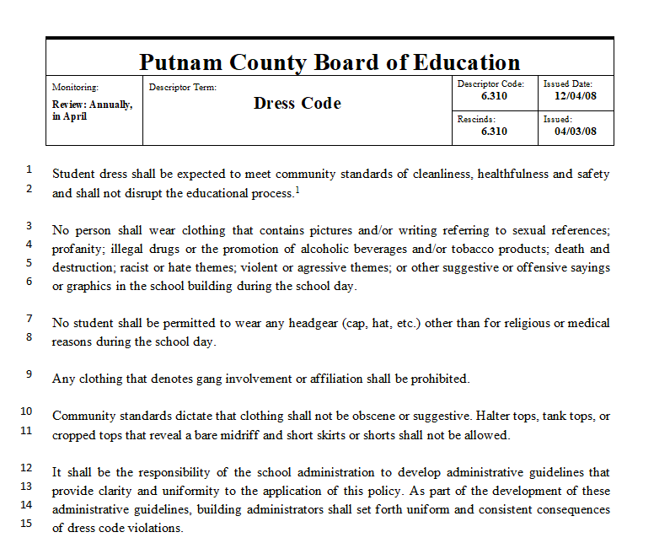

**Parent and Student Responsibility**

The parent and student will be responsible for ensuring that the student is in compliance with all aspects of this code when the student enters the school premises and during the time the student is on school premises during the regular school hours.

No apparel, accessory (i.e., jewelry), or any mode of appearance may display, advertise, or denote any of the following:

Gang affiliation or gang sign(s) or symbol(s) shall be prohibited

Alcohol or tobacco products

Profanity or vulgarity

Drugs and/or drug paraphernalia; including any related themes

Sexual theme or symbols

Racist overtures; hate themes or symbols

Themes of death or destruction

Violent, aggressive, or combative themes

Other suggestive or offensive sayings or graphics

Community Standards dictate that clothing shall not be obscene or suggestive. Halter tops, tank tops, or cropped tops that reveal a bare midriff and short skirts or shorts shall not be allowed.

It shall be the responsibility of the school administration to develop guidelines that provide clarity and uniformity to the application of this policy. As part of the development of theses administrative guidelines, building administrators shall set forth uniform and consistent consequences of dress code violations.



**Exception:** These standards of dress and grooming do not prohibit the principal or designee from allowing special celebrations that involve variations in dress and grooming. For such days, the principal or designee may set the guidelines of appropriate dress.

**Stricter Standards**

A stricter standard of dress and grooming may be imposed upon students for repeated violations of the dress code. For purposes of this policy, repeated violations will mean three or more violations during a school year. Discipline of dress code may include the following: warning, parent notification to bring appropriate clothing, student sent home for proper clothing, conference, in-school suspension, out-of-school suspension and other disciplinary actions deemed necessary by administration. (Policy 6.310)

**Backpacks/Book bags/Tote bags**

No backpacks with rollers will be acceptable without medical permission or approval from school administration.

**Student Concerns and Complaints- BPS follows PCSS District Policy 6.305**

**Conflicts between students** = Disagreements, bullying, name-calling, intimidation, or any other potential conflict(s) that could result in physical confrontation and/or could reasonably be considered to cause emotional distress should be reported to a school official immediately. Students are expected to resolve all conflicts in a nonviolent, non-threatening, and non-demeaning way.

**Decisional made by school personnel** (including Principals, Assistant Principals, Teachers, and Teacher Assistants) = Any decision which a student believes is unfair or in violation of pertinent policies of the Board or the individual school may be appealed to the Principal or a designated representative. To appeal, a student should contact the Principal’s office in his/her school and provide a name, the issue, and the reason for the appeal on a printed form available at the school office. This should be done within two (2) school days. The appeal will usually be decided confidentially and promptly, preferably within two (2) school days. If the Principal does not make a decision within two (2) school days following the date of the complaint, the student or parents may then appeal to the Director of Schools or designee at the Central Office. The information provided should include the student’s name, the school, and a description of the problem. An investigation and decision will be made within two (2) school days and communicated to the school Principal and the student by telephone. A written copy of the decision will then be sent to the student and to the Principal.

Bullying: According to Tennessee Code Annotated Section 49-6-1014 through 49-6-1019 and Putnam County School Board Policy 6.304, Baxter Primary School will provide a safe learning environment for student learning. Bullying should be reported immediately to a teacher, counselor, staff member or administration. Complaint manager will conduct an investigation and/or administration and consequences will be determined.

**Student Records per Family Educational Rights and Privacy Acts (FERPA**): A cumulative record shall be kept for each student enrolled in school. The folder shall contain a health record, attendance records, and academic record; shall be kept current; and shall accompany the student through his/her school career. Specific requirements of this law can be obtained from the school office.

Macintosh HD:Users:teacher:Desktop:Student Records Policy.pdf

**Bus Regulations**- *Riding the bus is a privilege.* Improper conduct can result in bus privileges being denied. If it is necessary for a student to ride a bus different from the regularly scheduled one, parents should send a note that includes the new destination address and contact numbers in case of questions. The note must be signed by the principal and given to the driver by the student when boarding the bus**. Any designated bus rider choosing NOT to ride the bus home on any given day must bring a note from home stating what the child is supposed to do. The principal must sign this note.**

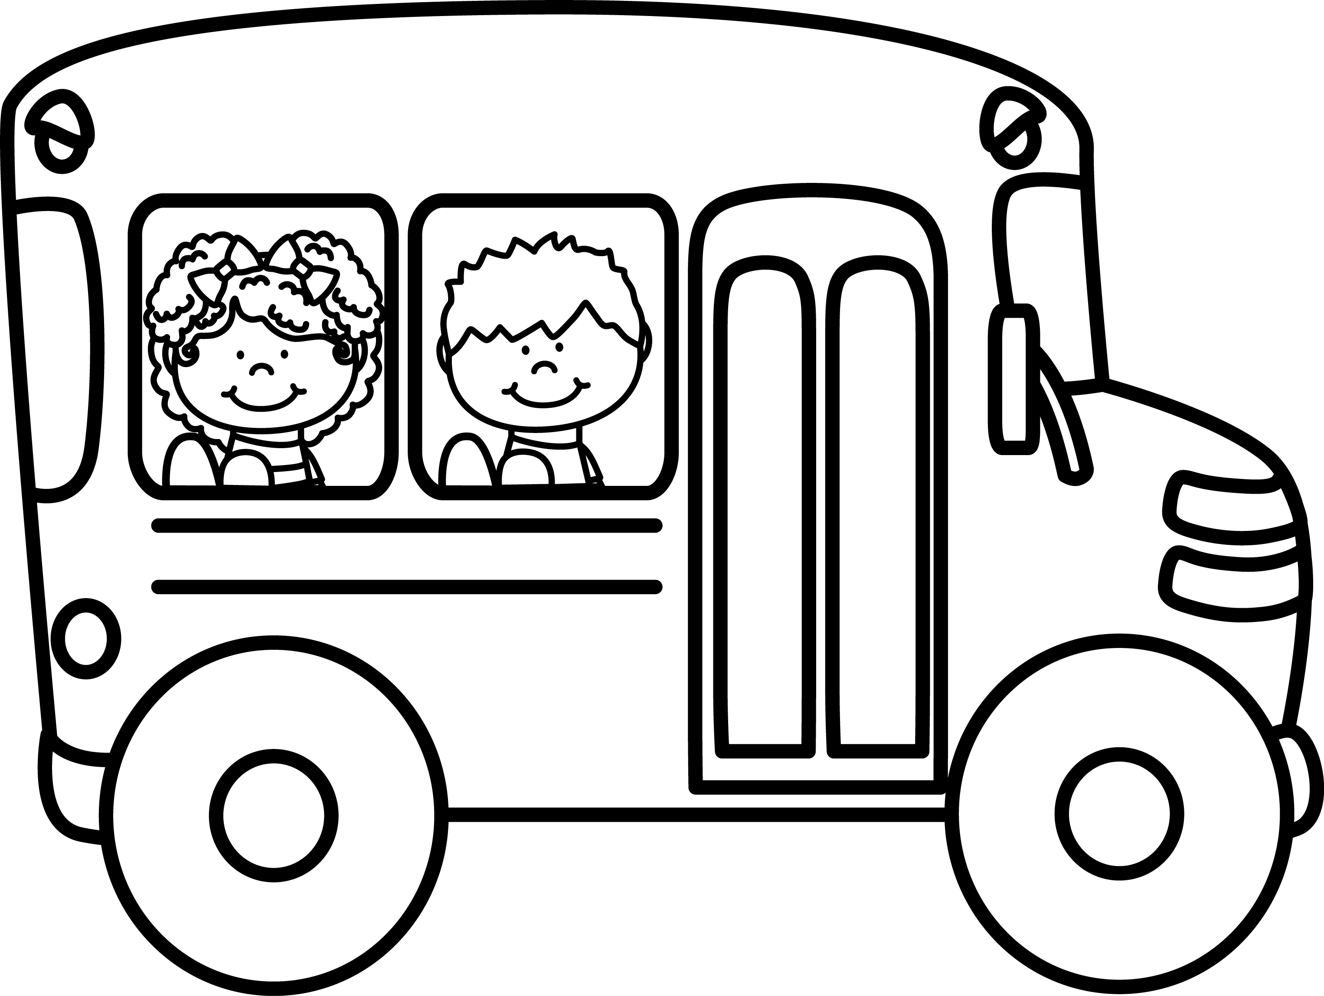

**Bus Service- District Policy** -**Pupil Transportation Rules and Regulations** –BPS follows PCSS Bus Conduct Policy 6.308. During each school year, thousands of children will ride the school buses to and from school. Although school buses are relatively safe, it is important for parents and to review some important safety rules with children when riding the school bus. Students are under the supervision and control of the bus driver while on the bus, and all reasonable directions given shall be followed by showing consideration and respect for the bus driver and your fellow students. The school bus is an extension of school activity; therefore, students shall conduct themselves on the bus in a manner consistent with the established standards for safety and classroom behavior. The bus driver has the responsibility for safety. Parents/Guardians will be held financially responsible for deliberate destruction of bus property. Riding a bus is a privilege extended to students and can be taken away at any time for disruptive or unsatisfactory conduct. Any acts of misconduct toward the bus driver while the student is on or off the bus will be dealt with by school administration. Consequences: 1st offense- warning 2nd offense- parent conference 3rd offense and all other offenses: Removal from bus

The bus driver shall inform the principal of any serious discipline problem. The principal may be called upon to assist if necessary. A student may be denied the privilege of riding the bus if the principal determines that the student’s behavior is such as to cause disruption on the bus, or if the student disobeys state or local rules and regulations pertaining to student transportation. Administration reserves the right to issue discipline according to severity of the offense. Students must bring a note to their classroom teacher that has been signed by their parents/guardians and a phone number to reach the parent/guardian during the school day if they are to ride any bus other than their normal bus. No student will be able to ride a bus other than their own without this verified documentation. Students may be denied this privilege due to over crowed buses. If you have a concern about a bus situation you may call Supervisor of Transportation at 526-9342.

**Sexual Discrimination- District Policy:** It is the policy of the Putnam County School District not to discriminate against any student, employee, or applicant on the basis of sex. The Putnam County School District will ensure that no student will be excluded from participating in or having access to any course offerings, student athletics, counseling services, employment assistance, extracurricular activities, or other school resources based on unlawful discrimination. The Putnam County School District will take all necessary steps to ensure that each student’s learning environment and each employee’s work environment is free of unlawful discrimination based on sex. No office, officer, or employee of the Putnam County School District shall intimidate, threaten, harass, coerce, discriminate against or seek reprisal against anyone who participates in any aspect of the discrimination complaint process associated with this policy.

**Handicapped Rights- District Policy** It is the policy of the Putnam County School District not to discriminate on the basis of handicap. The Putnam County School District will not:

1. Deny a qualified handicapped person the opportunity to participate in or benefit from any aid, benefit, or service the school district provides.

2. Afford a qualified handicapped person an opportunity to participate in or benefit from any aid, benefit, or service that is not equal to that is afforded to others.

3. Provide a qualified handicapped person with an aid, benefit, or service that is not as effective as that provided others.

4. Provide different or separate aid, benefits, or services to handicapped persons unless such action is necessary to provide qualified handicapped persons with aid, benefits, or services that are as effective as those provided to others.

5. Aid to perpetuate discrimination against a qualified handicapped person by providing significant assistance to any agency, organization, or person that discriminates on the basis of handicap in providing any aid, benefit, or service to the beneficiaries of the recipient’s program.

6. Deny a qualified handicapped person the opportunity to participate as a member of planning or advisory boards.

7. Otherwise limit a qualified handicapped person in the enjoyment of any right, privilege, advantage, or opportunity enjoyed by others receiving an aid, benefit, or service.

**Civil Rights Coordinator**

**Tennessee Department of Education**

**26th Floor, William Snodgrass Tower**

**312 Eighth Avenue North**

**Nashville, Tennessee 37243**

**Harassment/Discrimination- District Policy: Filing a complaint** = Any student who wishes to file a discrimination/harassment grievance against another student or an employee of the district may file a written or oral (recorded if possible) complaint with a complaint manager. Students may also report an allegation of discrimination/harassment to any teacher or other adult employed in the school, who shall inform a complaint manager of the allegation. The complaint should include the following information:(1) identity of the alleged victim or person accused, (2) location, date, time, and circumstances surrounding the alleged incident, (3) identity of witnesses, and (4) any other evidence available.

**Investigation** = Within twenty-four (24) hours of receiving the student’s complaint, the complaint manager shall notify the complaining student’s parent/guardian and the principal, who shall inform the Director of Schools. The parent/guardian shall be given notice of the right to attend an interview of the student in a non-intimidating environment in order to elicit full disclosure of the student’s allegations. The interview shall take place within five (5) days from the time the complaint was first made. If no parent/guardian attends the interview, another adult, mutually agreed upon by the student and the complaint manager, shall attend and may serve as the student’s advocate. After a complete investigation, if the allegations are substantiated, immediate and appropriate corrective or disciplinary action shall be initiated. The complaint and the identity of the complainant will not be disclosed except (1) as required by law or this policy; (2) as necessary to fully investigate the complaint; or (3) as authorized by the complainant. A school representative will meet with and advise the complainant regarding the findings and whether corrective measures and/or disciplinary actions were taken. The investigation and response will be completed within thirty (30) school days. Copies of the report shall be kept in the complaint manager’s file for one (1) year beyond the student’s eighteenth (18th) birthday. The Director shall keep the Board informed of all complaints.

**Add newest version of this letter**

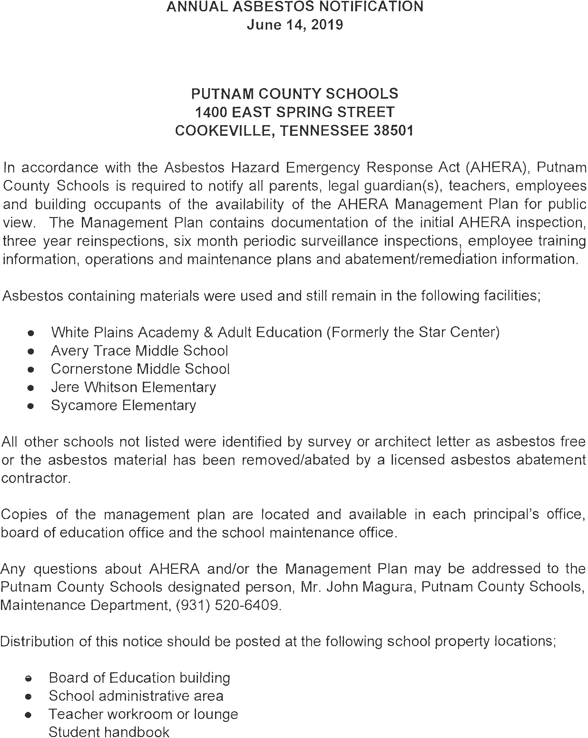

Faculty/Staff

Principal- Marsha Wyatt- [mwyatt@pcsstn.com](mailto:mwyatt@pcsstn.com)

Assistant Principal- Lacy Loggins- logginsl@pcsstn.com

Secretary- Sara Brown- sara.brown@pcsstn.com

Book Keeper- Jade Hunter- jhunter@pcsstn.com

Interventionist- - Carla Pierce- Carla.pierce@pcsstn.com

ELA Coach- Deloris Fowler- fowlered@pcsstn.com

Math Coach-Ashley Reeves- Ashley.reeves@pcsstn.com

Pre-K Coach- Allison Painter [paintera@pcsstn.com](mailto:paintera@pcsstn.com)

Nurse- Pam Turner- pam.turner@pcsstn.com

Pre-K Nurse- Lacie Fain- [lacie.fain@pcsstn.com](mailto:lacie.fain@pcsstn.com)

Psychologist- Samantha Farley- Samantha.farley@pcsstn.com

Speech- Kristie Burgess- [kristie.burgess@pcsstn.com](mailto:kristie.burgess@pcsstn.com)

Title I Assistant-Jennifer Tolomeo- Jennifer.tolomeo @pcsstn.com

Title I Assistant- TBD-

RTI Assistant- Misty Roach – misty.roach@pcsstn.com

SPED Teacher- Brittany Anderson- Brittany.anderson@pcsstn.com

Pre- K Teachers

Amanda Asberry- [aasberry1@pcsstn.com](mailto:aasberry1@pcsstn.com)

Brandi Malone- [maloneb2@pcsstn.com](mailto:maloneb2@pcsstn.com)

Samantha Chambers- Samantha.chambers@pcsstn.com

Macy Coupe- macy.coupe@pcsstn.com

Jaylyn Richardson-jaylyn.richardson@pcsstn.com

Christie Leftwich- [christileftwich@pcsstn.com](mailto:christileftwich@pcsstn.com)

Pre- K Assistants

Rachel Maynard- Rachel.maynard@pcsstn.com

Regina Sherell- [rsherrell@pcsstn.com](mailto:rsherrell@pcsstn.com)

Jessica Tidwell- [jessica.tidwell@pcsstn.com](mailto:jessica.tidwell@pcsstn.com)

Mindy Harp- mindy.harp@pcsstn.com

Julie Wilken- [Julie.wilken@pcsstn.com](mailto:Julie.wilken@pcsstn.com)

Claudia Webb- [Claudia.metzgar@pcsstn.com](mailto:Claudia.metzgar@pcsstn.com)

Phyliss Pedigo- [phyliss.pedigo@pcsstn.com](mailto:phyliss.pedigo@pcsstn.com)

Olivia Scott- [olivia.scott@pcsstn.com](mailto:olivia.scott@pcsstn.com)

Kindergarten Teachers

Shannon Haggard- [haggards@pcsstn.com](mailto:haggards@pcsstn.com)

Erica Miller- [erica.presley@pcsstn.com](mailto:erica.presley@pcsstn.com)

Kristina Penley- [penleyk@pcsstn.com](mailto:penleyk@pcsstn.com)

Ashlee Crain- ashlee.crain@pcsstn.com

Hayley Nemore- [Hayley.nemore@pcsstn.com](mailto:Hayley.nemore@pcsstn.com)

Madison Farley- [Madison.farley@pcsstn.com](mailto:Madison.farley@pcsstn.com)

*Assistant- Assistant- Anita Bryant- [abryant3@pcsstn.com](mailto:abryant3@pcsstn.com) and Tracey Pettit

First Grade Teachers Encore

Dana Carr- [dcarr@pcsstn.com](mailto:dcarr@pcsstn.com) Jamie Hull- School Counselor- Jamie.hull@pcsstn.com

Kristin Brown- [kristin.brown@pcsstn.com](mailto:kristin.brown@pcsstn.com) Laiton Pigg- Music-laiton.pigg@pcsstn.com

Natalie Crooks- natalie.crooks@pcsstn.com Nathan Davis- PE- [nathan.davis@pcsstn.com](mailto:nathan.davis@pcsstn.com)

Stacey May- Stacey.may@pcsstn.com Sandy Windrow- Librarian- [windrows@pcsstn.com](mailto:windrows@pcsstn.com)

Hailey Waller- Hailey.waller@pcsstn.com

Tonya Wade- [twade1@pcsstn.com](mailto:twade1@pcsstn.com)

Bell Brontrager- Claire.brontrager@pcsstn.com

*Assistants- Sandra Thomas and Tracey Pettit



BPS

2023-2024

School Calendar

(Please understand that these dates could change due to unforeseen reasons. If they do, updates will be posted to the Baxter Primary School Facebook page, emailed from admin./teachers, etc.)

**July:**

Friday 28th         Registration Day 10:00 Dismissal

Monday 31stth     Teacher Work Day -No Students

**August:**

Monday 1st     First Full Day of School and Back to School Bash (4:00-5:30pm)

Tuesday 22nd     Fall Pictures (Due Fri. Sept. 8th)

Thursday 31st Candy Bar Sale Kick-off (Due Fri. Sept 22nd)

**September:**

Monday 4th Labor Day -No School

Friday 8th            Grandparents Day during lunch and Fall Pictures Due

Monday 11th      Parent Teacher Conferences 3:30-6:00  Pre-K - 8

Monday 19th       Picture Retakes (Due Fri. Sept. 23rd)

Friday 22nd Candy Bar Sale Ends/End of Nine weeks/Picture Retake $ due

Thursday 29th      Literacy Night 5:00-6:30   Book Fair will be open during this event

Friday 30th End of 1st 9 weeks/Behavior Celebration/ Awards Day/ End of 1st 9 weeks

**October:**

October 3rd-14th Fall Break

Monday 17th        Review Behavior Expectations

Thursday 19th    Report Card #1

Friday 20th Pops and Pumpkins (Kindergarten) at 1:30pm

Monday 22-27th Book Fair Week (can shop 7:15-7:45) and Red Ribbon Week

Monday 23rd Pumpkin Book Character (library activity throughout the week)

Thursday 26th Holiday pictures During the day for all students

Thursday 26th Literacy Night and Holiday pictures (5:00-6:30pm)

Tuesday 31st Trunk or Treat and Judging of Pumpkins

**November:**

Friday 10th Veterans Program 8:30 a.m.

Friday 10th Holiday Picture money due

Monday 21st           Thanksgiving Feast (school-wide)

November 23-25 Thanksgiving Holiday – No school

Tuesday 28th Pictures with Santa (PTO sponsored)

**December:**

Friday 1st Food Dive begins (in honor of Mr. King)

Week of 4rd- 8th  Holiday Shoppe (PTO sponsored- this is optional)

Tuesday 12th           Christmas Musical (times to come at a later date)

Friday 15th           Food Drive ends

Tuesday 19th        End of 2nd 9 weeks, Awards Day & Christmas times for each grade will be shared at

a later date

Dec. 20th-Jan. 3rd    Winter Break

**January:**

Wednesday 3rd   Begins 2nd semester

Thursday 11th     Report Card #2

Monday 15th       Martin Luther King Holiday -No school

Friday 19th 100th day of school

**February:**

Monday 5th        Winter Parent Teacher Conferences (3:30-6:00pm)

Wednesday 14th       Valentine’s Day Parties

Monday 19th       Presidents’ Day Holiday - No School

Monday 26th-March 4th Book Fair week- Book Fair Shopping during lunch all grades

Thursday 29th Family Engagement Event (5:00-6:30pm)

**March:**

Friday 1st Dr, Suess Day Cat in the Hat Character Dress Up Day

Tuesday 5th Election Day- No School

Friday 8th          Behavior Celebration & Awards Day - End of 3rd Nine Weeks

Monday 11-15th         Spring Break

Thursday 21st   Report Card #3

Tuesday 26th     Group, Spring, Cap & Gown, Easter Bunny Pictures (Due Fri. April 19th)

1st Grade Musical (time will be announced closer to date)

Thursday 28th Festival of Movement (PE activity at Hooper Eblen Center-Students will be

chosen by PE teacher)

Thursday 29th Easter Egg Hunt (School-wide- time to be announced closer to date)

Friday 29th Easter Holiday (no school)

**April:**

Monday 1st Easter Holiday (no school)

TBA Kindergarten Registration

Tuesday 23rd Kindergarten musical (time will be announced closer to date)

Saturday 27nd          SuperHero Ball

Tuesday 25th     Kindergarten Musical 5:30 p.m.

**May:**

6th-10th Teacher Appreciation Week

Friday 10th    1st grade Transition visit to Cornerstone

Friday 17th k to 1st transition day

Friday 17th PreK to K transition day

Monday 20th FUN DAY school-wide (PTO Sponsored) and Talent Show

Tuesday 21st End of the Year Awards  (Pre-K-11:00  K-1:00  1st-8:30)

Thursday 23rd   Teacher Work Day

Friday 24th        Last Day of School 10:00 Dismissal



Baxter Primary Handbook

2023-2024

I have read the Baxter Primary School handbook for 2023-2024 school year. I understand the rules and procedures that are explained in the handbook. I have discussed these rules and procedures with my child. Please detach, sign and return to student’s teacher.

Parent signature __________________________________Date____________________

Student Signature_________________________________ Date____________________

Teacher Signature_________________________________Date____________________